Purchase Order Template  A blank template can be found on page two. | 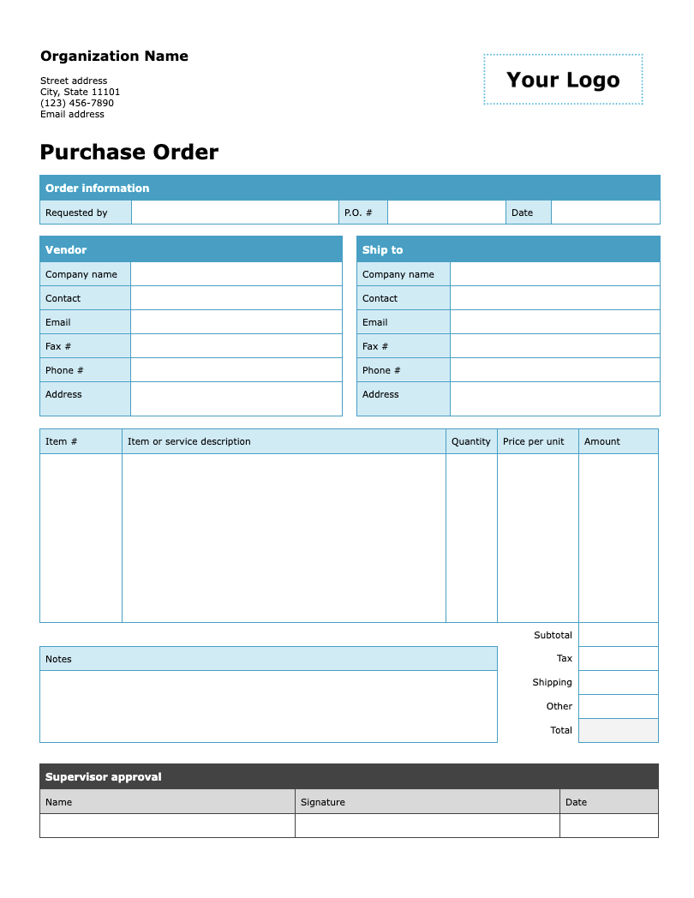

Follow these steps to get started

- Update the organization information by replacing the placeholder text with your organization's name, address, phone number, and email address.
- Add your logo by clicking on “Your Logo.” Then go to Insert > Picture and select the file you want to upload. The new image will automatically replace the placeholder.
- Adjust the fields and options on the form as needed.
- Remove this instruction page and distribute a copy to your colleagues to fill out and submit.

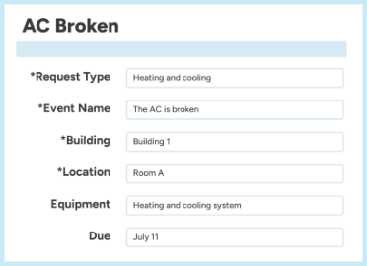 | Centralize your work order process with innovative, easy-to-use software.  Discover a smarter workflow with FMX

Organization Name  Street address  City, State 11101  (123) 456-7890  Email address | 

Purchase Order
Order information
Requested by |  | P.O. # |  | Date

Vendor |  |  | Ship to
Company name |  |  | Company name
Contact |  |  | Contact
Email |  |  | Email
Phone # |  |  | Phone #
Fax # |  |  | Fax #
Address |  |  | Address

Item # | Item or service description | Quantity | Price per unit | Amount
 |  |  | Subtotal
Notes |  |  | Tax
 |  |  | Shipping
 |  |  | Other
 |  |  | Total

Supervisor approval
Name | Signature | Date

